1. Open EclipseC++ create a new C++ project called “CMUGraphicsLib”
2. Copy and paste the**contents** of the CMUGraphicsLib folder on Student Work into your new project workspace.
3. Next, create a another new C++ project called “CMUDemo”
4. Right click and select properties
5. Go to C/C++ Build > Settings>GCC C++ Compiler > Includes. Click the add button and find the library folder inside the CMU folder you just added to your library."${workspace_loc:/CMUGraphicsLib/CMUgraphicsLib}"
6. Next, go to MinGW C++ Linker > Libraries and add the following to the library list

“cmugraphics”

“winmm”

“gdi32”

1. Under Library Search Path add your new library folder. "${workspace_loc:/CMUGraphicsLib}"

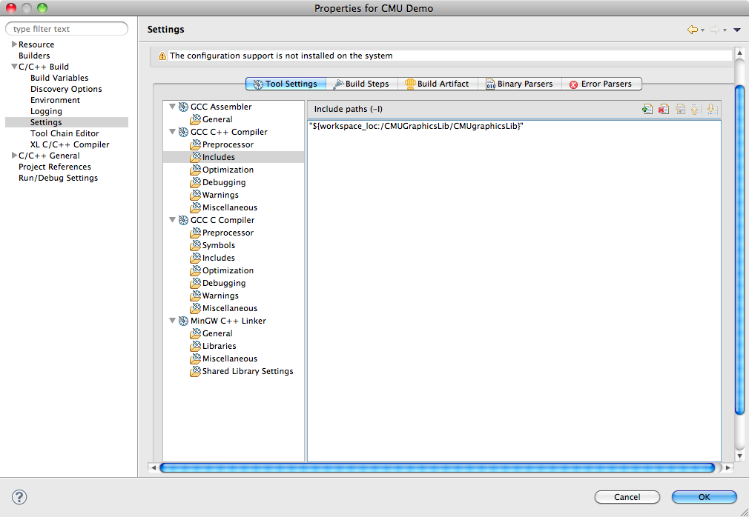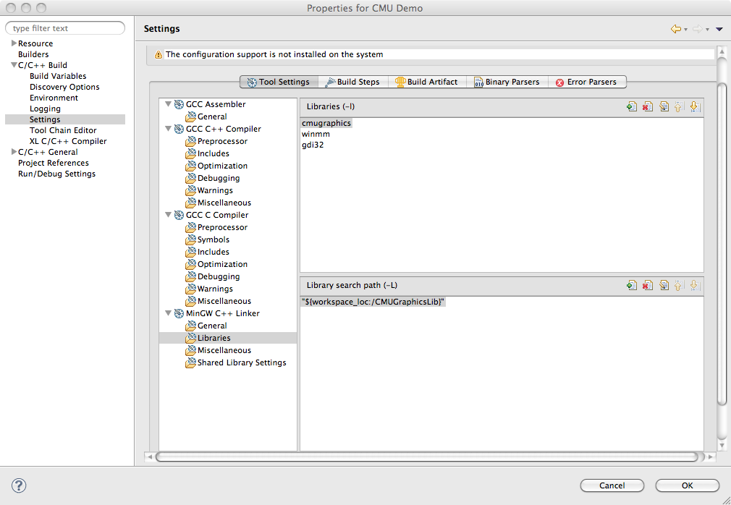

1. You’re done! CMU Graphics Library should now be fully linked to your project. Simply add #include “CMUgraphics.h” to your source for complete access to all the gui API’s.

Go to the next page to run an example of the CMU graphics package.

1. Next go to CMUDemo and create a new C++ source file called “house.cpp” and paste the following code:

**#include** <iostream>

**#include** <cmath>

**#include** <CMUgraphics.h>

**using** **namespace** std;

// global constants

**const** **int** HOUSE_WIDTH = 400;

**const** **int** HOUSE_HEIGHT = 200;

**const** **int** DOOR_WIDTH = 30;

**const** **int** DOOR_HEIGHT = 50;

**const** **int** WINDOW_WIDTH = 50;

**const** **int** WINDOW_HEIGHT = 70;

// declarations

**void** **DrawHouse**();

**void** **DrawFrame**(**int** x, **int** y);

**void** **DrawDoor**(**int** x, **int** y);

**void** **DrawWindows**();

**void** **DrawWindow**();

// global window object, 700x400 at (5,5)

window myWindow(700, 400, 5, 5);

**int** **main**() {

cout << "Hit <enter> once you've resized and moved the Console";

cout << " window out of the way...\n";

cin.ignore();

DrawHouse();

**return** 0;

}

**void** **DrawHouse**() {

**int** x, y;

cout << "You will be asked for the coordinates of the top left corner of the house.\n";

cout << "100,150 is a good choice.\n\n";

cout << "Enter x coordinate of house (top left): ";

cin >> x;

cout << "Enter y coordinate of house (top left): ";

cin >> y;

DrawFrame(x,y);

DrawDoor(x,y);

DrawWindows();

}

**void** **DrawFrame**(**int** x, **int** y) {

myWindow.SetPen(BROWN);

myWindow.SetBrush(BROWN);

myWindow.DrawRectangle(x, y, x + HOUSE_WIDTH, y + HOUSE_HEIGHT, *FILLED*);

myWindow.SetPen(BLACK);

myWindow.DrawLine(x, y, x + HOUSE_WIDTH/2, y - HOUSE_HEIGHT/2);

myWindow.DrawLine(x + HOUSE_WIDTH, y, x + HOUSE_WIDTH/2, y - HOUSE_HEIGHT/2);

}

**void** **DrawDoor**(**int** x, **int** y) {

myWindow.SetPen(BLACK);

myWindow.SetBrush(BLACK);

myWindow.DrawRectangle(x + HOUSE_WIDTH/2 - DOOR_WIDTH/2, y + HOUSE_HEIGHT - DOOR_HEIGHT,

x + HOUSE_WIDTH/2 + DOOR_WIDTH/2, y + HOUSE_HEIGHT, *FILLED*);

}

**void** **DrawWindows**() {

**int** i, n;

cout << "How many windows? ";

cin >> n;

**for** (i = 0; i < n; i++) {

DrawWindow();

}

}

**void** **DrawWindow**() {

**int** x, y;

cout << "Click top left corner of window location." << **endl**;

myWindow.WaitMouseClick(x, y);

myWindow.SetPen(BLACK);

myWindow.SetBrush(WHITE);

myWindow.DrawRectangle(x, y, x + WINDOW_WIDTH, y + WINDOW_HEIGHT, *FILLED*);

myWindow.SetPen(BLACK);

myWindow.DrawLine(x, y + WINDOW_HEIGHT/2, x + WINDOW_WIDTH, y + WINDOW_HEIGHT / 2);

myWindow.DrawLine(x + WINDOW_WIDTH/2, y, x + WINDOW_WIDTH/2, y + WINDOW_HEIGHT);

}